Complainant contact
Early communication is a crucial part of any complaint handling.
Making direct telephone contact with the complainant builds rapport, enables you to exchange information quickly and sets the boundaries and expectations for the complaint handling. The complainant will see that you are taking the dissatisfaction seriously and will resolve it. Speak in an open and honest way, bearing in mind that the complainant is unlikely to have any knowledge of police jargon or processes.
When recording the complaints, please consider the data capture guidance and for more examples, the data capture edition of Focus.

Complainant contact checklist
☐ Agree contact method
☐ Contact service user by telephone
☐ Have you understood the complaint?
☐ Agree heads of complaint
☐ Explain the police complaints process
☐ Discuss potential outcomes
☐ Manage service user expectations
☐ Confirm agreed complaints in writing

Decision making
See Focus issue 13 – Handling complaints: decisions and thresholds.
The Relevant Review Body test is based on the wording of the complaint alone and the decision is taken at the start of handling the complaint.

The decision on whether a matter needs to be investigated or not can only take into consideration the evidence that you have readily available. Explain here what that evidence is and how you’ve come to your decision. Investigating or not has important implications as to the outcomes that can be obtained when concluding the handling of the complaint.

Consider NFA; is it reasonable and proportionate to take no further action? For example have all complaints previously been recorded and handled under schedule 3? Is the matter about off duty behaviour? Is the complaint actually about another process and not a police complaint? Provide rationale.

Decision making checklist
☐ Who is the Relevant Review Body (RRB)?
☐ OTBI or Investigation or NFA? Provide rationale.
☐ If Investigation, is the Special Procedures (SP) decision documented?

Evidence gathering
This is a vital part of handling the complaint. Think about what evidence you will need to gather and how it will help you determine the outcomes of the complaint. Consider reasonable lines of enquiry and the necessity and proportionality of pursuing them. Some evidence will be necessary to come to an informed and robust decision that stands up to scrutiny. If you don’t think some evidence will need to be obtained will that decision stand up to scrutiny? Explain your decisions to obtain or not obtain evidence here.

Evidence gathering checklist
☐ BWV
☐ CCTV
☐ Call handling recording
☐ Custody record
☐ Incident Log
☐ Use of force form
☐ Witness statements
☐ Officer accounts – written, verbal, statement, interview. If none are needed, why not? Record the rationale
☐ Record of stop and search/search of premises/traffic stop
☐ Other – medical, independent witnesses, expert opinion
☐ Consider relevant policies – force policies, College of Policing APP
☐ Consider any relevant legislation
☐ Evidence/information supplied by complainant

Evaluation of evidence
This is where you bring all the evidence together and analyse it.
For SP Investigation, analyse the evidence and make a determination whether there is a case to answer for misconduct or gross misconduct and provide rationale.
For investigations and OTBI make a decision on whether the service provided is acceptable. It is not enough to repeat the evidence and then conclude the complaint - there must be a clear rationale as to why you believe particular pieces of evidence to be strong and worthy of bringing you to the outcomes you have reached.

Evaluating the evidence (for each allegation)
☐ What weight will you attribute to the evidence?
☐ Does the evidence support the allegation?
☐ What is weak/what is strong evidence?
☐ Consider whether the situation could have been handled differently/better?
☐ Consider the evidence; credibility, reliability, accuracy and weight

Writing Up
Use empathetic, easily understandable language. Don’t forget that something you take for granted because of your policing role might not be apparent to the complainant - they are unlikely to be aware of police powers and procedures.

Writing up checklist
☐ List the complaints
☐ Summarise the evidence
☐ Consider legislation/policies/guidance
☐ State a conclusion for each complaint – (was the service acceptable for allegations not subject to special procedures? Is there a case to answer in cases subject to special procedures?)
☐ Provide rationale/thought process for each decision
☐ Show workings out/explain
☐ Decision needs to be based on evidence
☐ Use empathetic language and show understanding
☐ Tone – balanced, not defensive, nor blaming, but be robust

Outcomes
See Focus issue 18 – Reasonable and proportionate outcomes, IOPC Statutory guidance (Chapter 3 R&P), See Focus 21 for RPRP, See Home Office Guidance on on Professional Standards, performance and integrity in policing and IOPC Statutory Guidance (Para 17.9-18.41)
When handling a complaint other than by investigation and investigations not subject to special procedures, you need to decide whether the service received has been acceptable or not. Outcomes should focus on learning, reflection, improvement and explanations. When investigating a complaint subject to special procedures, the AA will need to make decisions on whether or not there is a case to answer.

Outcomes checklist
☐ Use remedies. Is there learning, explanation or an apology needed? If so; acknowledge, explain and apologise.
☐ Learning – RPRP, individual learning from reflection, organisational
☐ More serious cases (SP INVs) is there a case to answer/referral to CPS. Explain your decision. (Focus 13)
☐ Review rights – is it clear for the service user how to submit a request for a review and to which review body?

Published March 2024
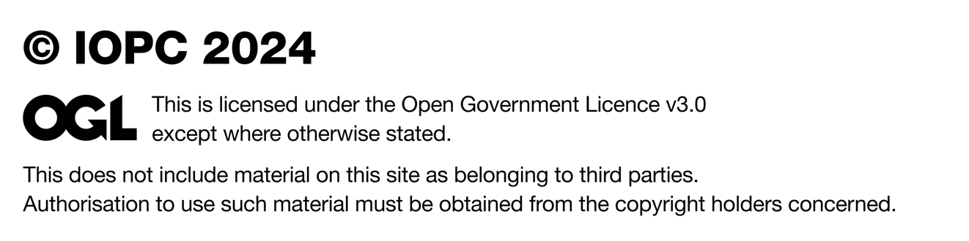

To find out more about our work or to request this report
in an alternative format, you can contact us in a number of ways:

Independent Office for Police Conduct (IOPC)
10 South Colonnade Canary Wharf London E14 4PU
Tel: 0300 020 0096
Email: enquiries@policeconduct.gov.uk
Website: www.policeconduct.gov.uk
Text relay: 18001 020 8104 1220

We welcome telephone calls in Welsh
Rydym yn croesawu galwadau ffôn yn y Gymraeg

